**MACHINE PROBLEM NO. 2**

Screenshots and Proof of Testing

**CODE:**

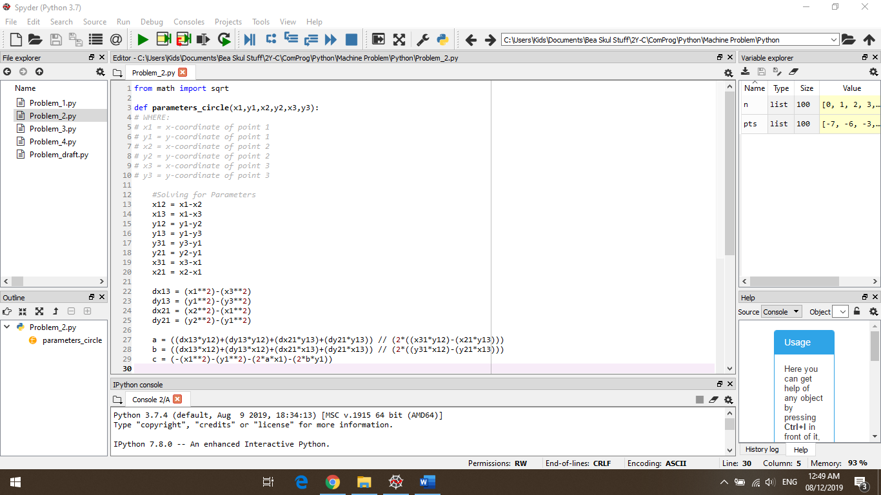

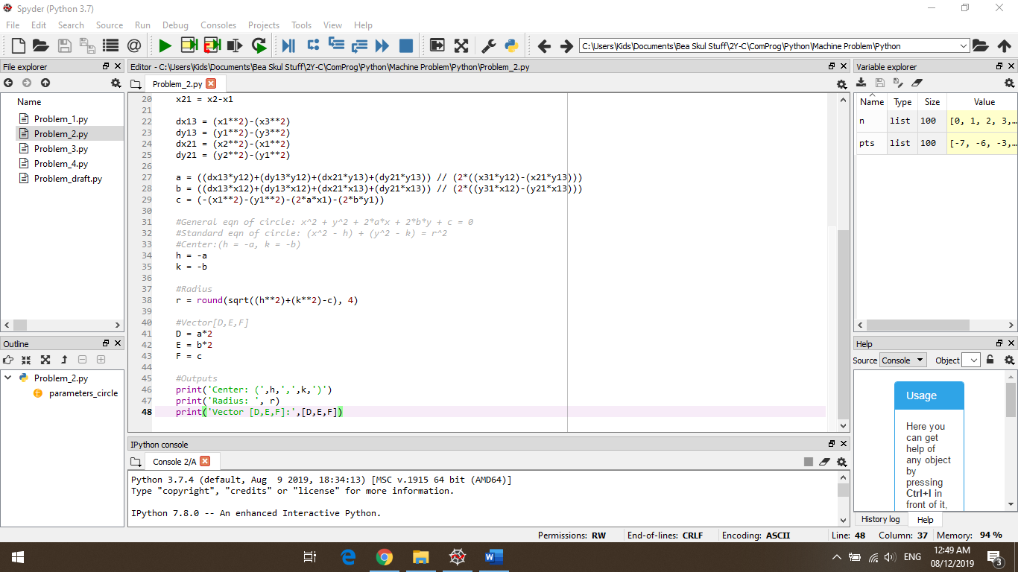

**TRIAL #1:**

* Points entered: (1,1), (2,4), and (5,3)

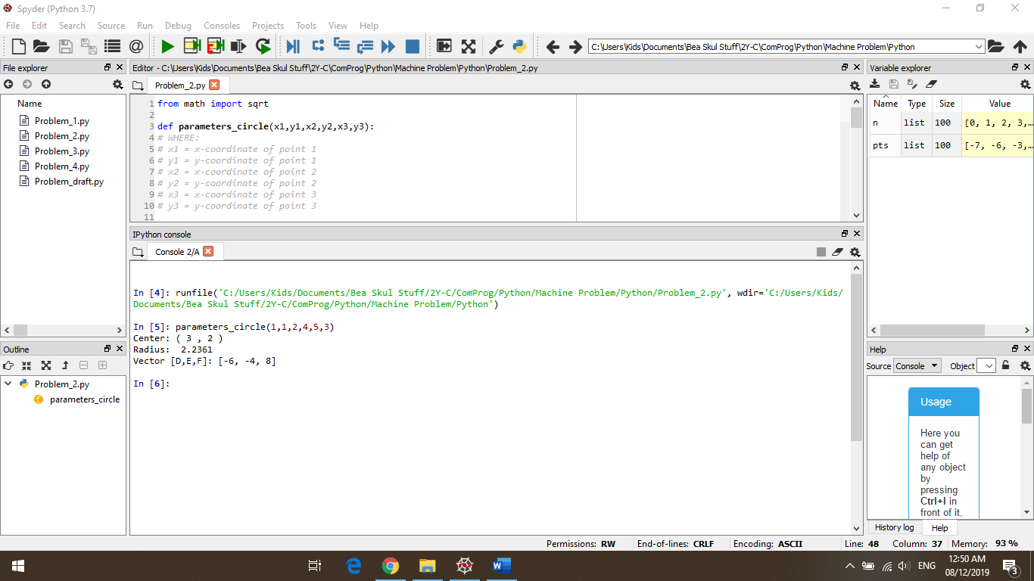

**TRIAL #2:**

* Points entered: (-3,4), (4,5), and (1,-4)

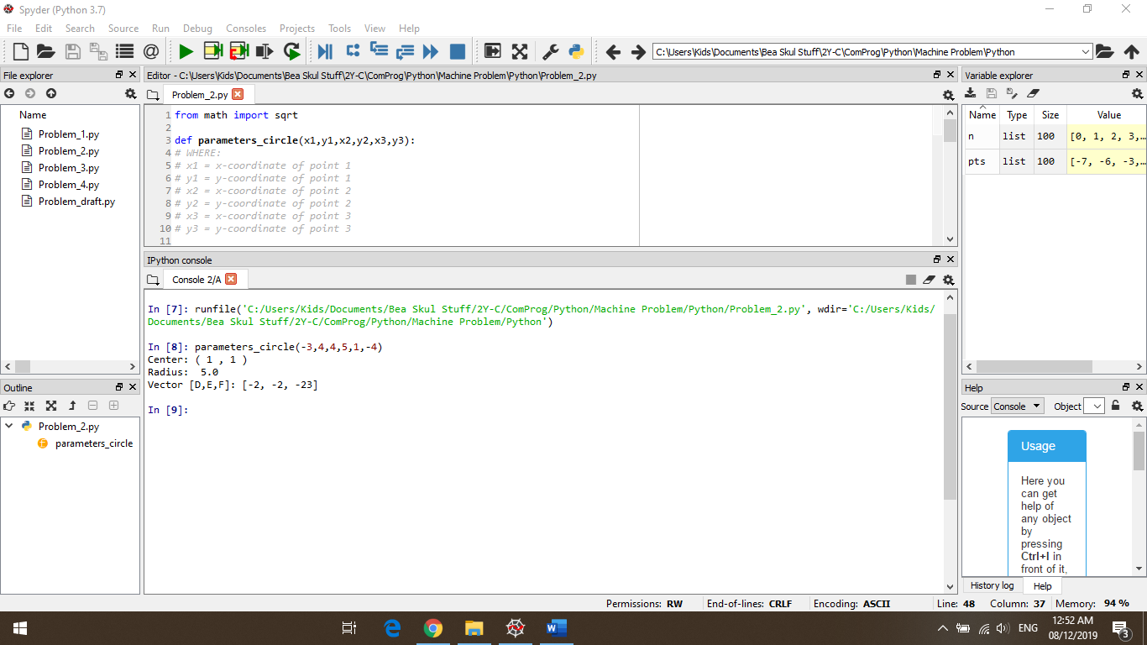

**TRIAL #3:**

* Points entered: (0,4), (3,5), and (7,3)

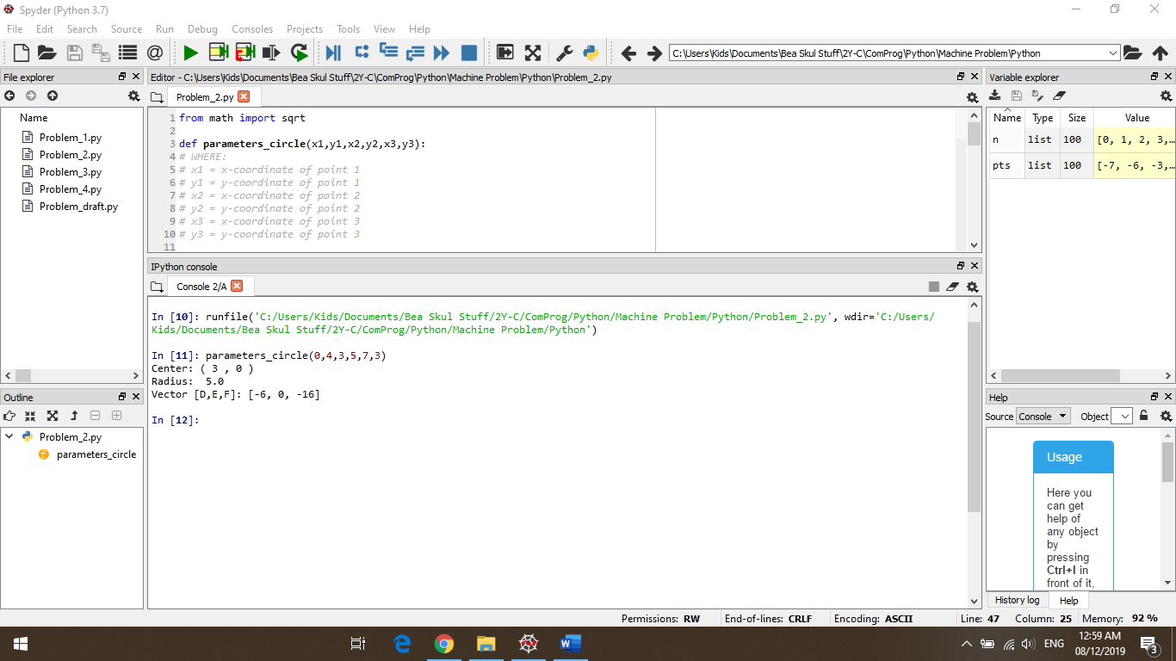

**TRIAL#4:**

* 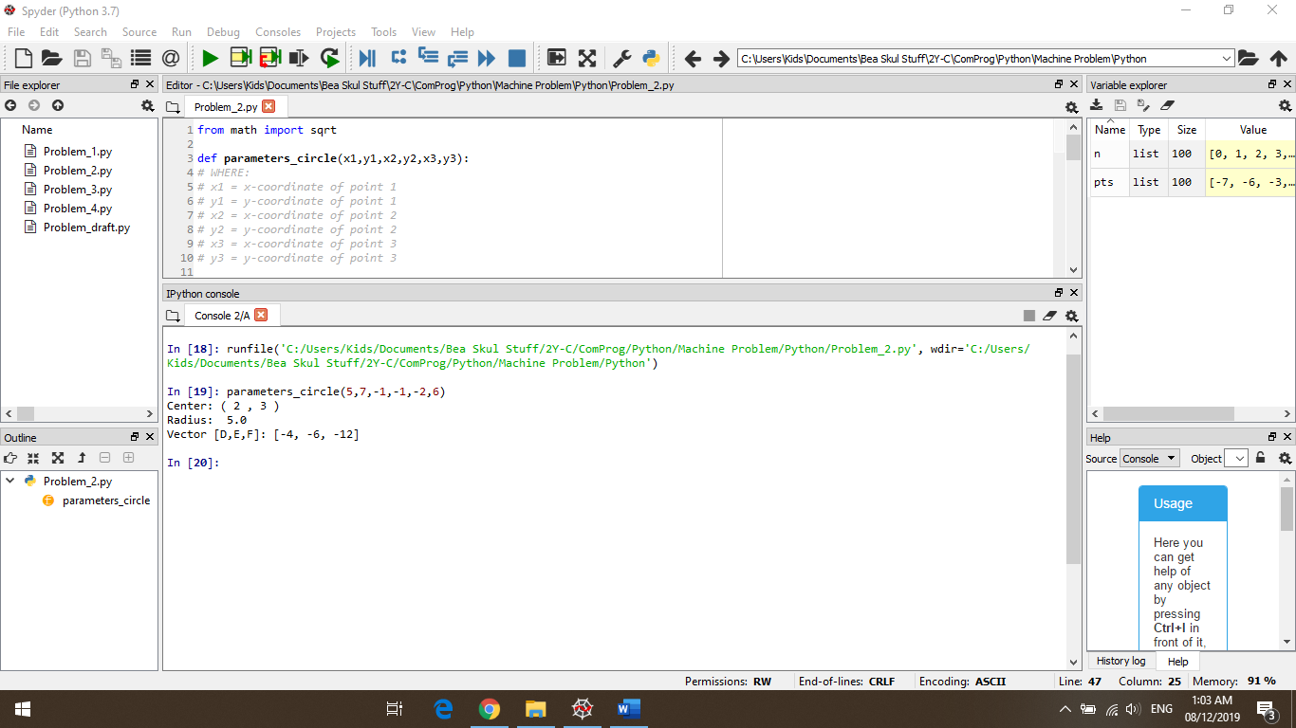Points entered: (5,7), (-1,-1), and (-2,6)